Installation

**1. Backup your web directory and store database.**

Before installing the plugin, make sure to backup your files and database.

If you are going to use the native Magento backup function, navigate to **System -> Backups-> Backups** and perform ***System*** and ***Database*** backups

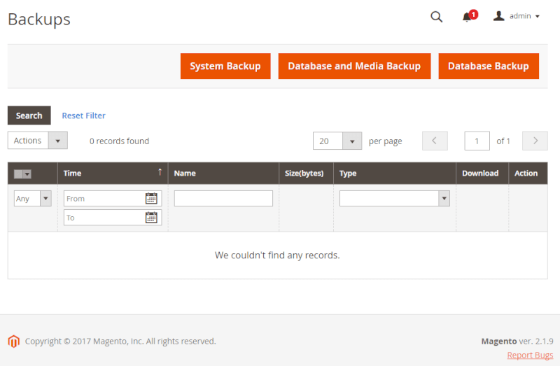

**2. Using FileZilla (or any FTP application) Open FTP Connection.**

**3. Copy the folder named code into the root directory of magento 2 /app/**

**4. Change the folder permission to 755 and apply it to all your subfolders and files under it.  
5. using ssh (cli mode) enter the following commands :**

* **php bin/magento setup:upgrade**
* **php bin/magento module:enable Vbout_Plugin --clear-static-content**
* **php bin/magento setup:di:compile**
* **php bin/magento cache:clean**